***FRONT-BACK END WEB DEVELOPMENT***

***Documentation***

**Project Risk Assessment**

The top three high probability and high impact risks to this project are:

*1. Late in the project, there are a lot of changes that need to be made.*

If stakeholders plan to make significant adjustments to the way sections of the platform are programmed/designed to run, the project's planned delivery may be delayed, and the website may even need a major redesign.

*2. Unexpected program flaws (bugs)*

If software bugs are not discovered or resolved quickly enough, they can escalate as the website grows. This could cause the website's completion to be postponed or even cause it to suffer an over haul. These software anomalies may be the result of human error, hardware and software incompatibility, or flaws in the project team's development tools.

*3. Sick/urgent leave/quits*

The project will be significantly delayed if the developer is still recovering.

|  |  |  |  |
| --- | --- | --- | --- |
| Risk No: | Description | Impact Description | Risk probability |
| 4 | Content will not be available when required | Failure to meet the deadline would result in a reduction in funding. | 8 |
| 5 | Resources for this project can be reallocated to other (higher) priority projects. | This project currently has all of its resources dedicated to it. The loss of a resource would cause the project to be significantly delayed. | 5 |
| 6 | End users can be wary of the new site's workflow. | Customer input was crucial in the development of the site, but not all users would appreciate the improvements. It's possible that this could result in negative attention or a lack of customer satisfaction. | 8 |
| 7 | Data loss | Customer data may be lost as a result of data migration. Customer data is critical for day-to-day operations. | 7 |

**ERD Diagram**

1)

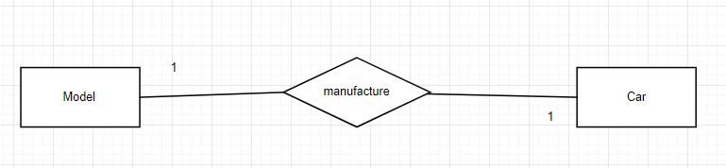

2)

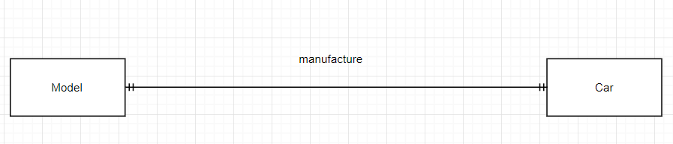

The Car column stores the cars, and The Model column stores a production of models within the car.

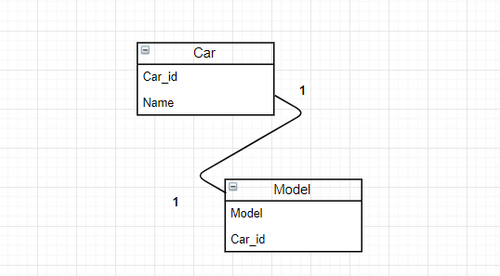

Car is the first table, and it has two columns: Car_id and Name. Model is the second table, and it includes two columns: Car_id and model. The two Car_id columns have a one-to-one relationship. The relationship filters in both directions, which is always the case for one-to-one relationships.

**UML**

